https://colab.research.google.com/notebooks/intro.ipynb#scrollTo=JQesyTg7QSU-
Mount from google drive

from google.colab import drive
drive.mount('/content/drive')

Import Libraries

import os
import numpy as np
import pandas as pd
import matplotlib.pyplot as plt
import seaborn as sns
from PIL import Image
from sklearn.model_selection import train_test_split, cross_val_score, GridSearchCV
from sklearn.preprocessing import StandardScaler
from sklearn.decomposition import PCA
from sklearn.svm import SVC
from sklearn.ensemble import RandomForestClassifier
from sklearn.neighbors import KNeighborsClassifier
from sklearn.naive_bayes import GaussianNB
from sklearn.neural_network import MLPClassifier
from sklearn.metrics import classification_report, confusion_matrix, accuracy_score, roc_auc_score
from sklearn.pipeline import Pipeline

print("✅ Libraries imported successfully!")

Load and Explore Dataset

# Set your dataset path
dataset_path = '/content/drive/My Drive/Colab Notebooks/TB_Chest_Radiography_Database/'
normal_path = os.path.join(dataset_path, 'Normal')
tb_path = os.path.join(dataset_path, 'Tuberculosis')

def explore_dataset():
"""Explore the TB chest radiography dataset"""

# Count images
normal_images = [f for f in os.listdir(normal_path) if f.lower().endswith(('.png', '.jpg', '.jpeg'))]
tb_images = [f for f in os.listdir(tb_path) if f.lower().endswith(('.png', '.jpg', '.jpeg'))]

print("📊 DATASET EXPLORATION:")
print(f"✅ Normal chest X-rays: {len(normal_images)}")
print(f"✅ Tuberculosis chest X-rays: {len(tb_images)}")
print(f"📈 Total images: {len(normal_images) + len(tb_images)}")
print(f"⚖️ Class balance - Normal: {len(normal_images)/(len(normal_images)+len(tb_images)):.2%}")
print(f"⚖️ Class balance - TB: {len(tb_images)/(len(normal_images)+len(tb_images)):.2%}")

# Check image dimensions
if normal_images:
sample_img = Image.open(os.path.join(normal_path, normal_images[0]))
print(f"📐 Sample image dimensions: {sample_img.size}")
print(f"🎨 Image mode: {sample_img.mode}")

return normal_images, tb_images

normal_images, tb_images = explore_dataset()

Feature Extraction from images

def extract_features(image_paths, label):
"""Extract features from chest X-ray images"""
features = []
target_labels = []

print(f"🔄 Extracting features from {len(image_paths)} images...")

for i, img_path in enumerate(image_paths):
if i % 50 == 0 and i > 0:
print(f" Processed {i}/{len(image_paths)} images...")

try:
# Load and preprocess image
img = Image.open(img_path).convert('L') # Convert to grayscale
img = img.resize((128, 128)) # Resize for consistent dimensions

# Convert to numpy array
img_array = np.array(img)

# Extract multiple types of features
image_features = []

# 1. Statistical features
image_features.extend([
np.mean(img_array), # Mean intensity
np.std(img_array), # Standard deviation
np.median(img_array), # Median
np.min(img_array), # Minimum
np.max(img_array), # Maximum
np.percentile(img_array, 25), # 25th percentile
np.percentile(img_array, 75), # 75th percentile
])

# 2. Histogram features (intensity distribution)
hist, _ = np.histogram(img_array, bins=32, density=True)
image_features.extend(hist[:10]) # Use first 10 histogram bins

# 3. Texture features (simplified)
# Horizontal and vertical gradients
grad_x = np.diff(img_array, axis=1)
grad_y = np.diff(img_array, axis=0)
image_features.extend([
np.mean(np.abs(grad_x)),
np.mean(np.abs(grad_y)),
np.std(grad_x),
np.std(grad_y)
])

# 4. Regional features (divide image into 4 quadrants)
h, w = img_array.shape
regions = [
img_array[:h//2, :w//2], # Top-left
img_array[:h//2, w//2:], # Top-right
img_array[h//2:, :w//2], # Bottom-left
img_array[h//2:, w//2:] # Bottom-right
]

for region in regions:
image_features.extend([np.mean(region), np.std(region)])

features.append(image_features)
target_labels.append(label)

except Exception as e:
print(f"❌ Error processing {img_path}: {e}")
continue

print(f"✅ Feature extraction completed! Total samples: {len(features)}")
return np.array(features), np.array(target_labels)

# Only proceed if we have the dataset
if normal_path and tb_path and normal_images and tb_images:
print("📁 Preparing image paths...")
normal_image_paths = [os.path.join(normal_path, img) for img in normal_images]
tb_image_paths = [os.path.join(tb_path, img) for img in tb_images]

print("🔨 Extracting features from Normal images...")
X_normal, y_normal = extract_features(normal_image_paths, 0) # 0 = Normal

print("🔨 Extracting features from TB images...")
X_tb, y_tb = extract_features(tb_image_paths, 1) # 1 = Tuberculosis

# Combine datasets
X = np.vstack([X_normal, X_tb])
y = np.hstack([y_normal, y_tb])

print(f"🎯 Final dataset shape: {X.shape}")
print(f"🎯 Labels distribution: {np.unique(y, return_counts=True)}")
print(f" - Class 0 (Normal): {np.sum(y == 0)} samples")
print(f" - Class 1 (TB): {np.sum(y == 1)} samples")
else:
print("❌ Cannot proceed - dataset not properly loaded")

output
📁 Preparing image paths...
🔨 Extracting features from Normal images...
🔄 Extracting features from 3500 images...
Processed 50/3500 images...
Processed 100/3500 images...
Processed 150/3500 images...
Processed 200/3500 images...
Processed 250/3500 images...
Processed 300/3500 images...
Processed 350/3500 images...
Processed 400/3500 images...
Processed 450/3500 images...
Processed 500/3500 images...
Processed 550/3500 images...
Processed 600/3500 images...
Processed 650/3500 images...
Processed 700/3500 images...
Processed 750/3500 images...
Processed 800/3500 images...
Processed 850/3500 images...
Processed 900/3500 images...
Processed 950/3500 images...
Processed 1000/3500 images...
Processed 1050/3500 images...
Processed 1100/3500 images...
Processed 1150/3500 images...
Processed 1200/3500 images...
Processed 1250/3500 images...
Processed 1300/3500 images...
Processed 1350/3500 images...
Processed 1400/3500 images...
Processed 1450/3500 images...
Processed 1500/3500 images...
Processed 1550/3500 images...
Processed 1600/3500 images...
Processed 1650/3500 images...
Processed 1700/3500 images...
Processed 1750/3500 images...
Processed 1800/3500 images...
Processed 1850/3500 images...
Processed 1900/3500 images...
Processed 1950/3500 images...
Processed 2000/3500 images...
Processed 2050/3500 images...
Processed 2100/3500 images...
Processed 2150/3500 images...
Processed 2200/3500 images...
Processed 2250/3500 images...
Processed 2300/3500 images...
Processed 2350/3500 images...
Processed 2400/3500 images...
Processed 2450/3500 images...
Processed 2500/3500 images...
Processed 2550/3500 images...
Processed 2600/3500 images...
Processed 2650/3500 images...
Processed 2700/3500 images...
Processed 2750/3500 images...
Processed 2800/3500 images...
Processed 2850/3500 images...
Processed 2900/3500 images...
Processed 2950/3500 images...
Processed 3000/3500 images...
Processed 3050/3500 images...
Processed 3100/3500 images...
Processed 3150/3500 images...
Processed 3200/3500 images...
Processed 3250/3500 images...
Processed 3300/3500 images...
Processed 3350/3500 images...
Processed 3400/3500 images...
Processed 3450/3500 images...
✅ Feature extraction completed! Total samples: 3500
🔨 Extracting features from TB images...
🔄 Extracting features from 700 images...
Processed 50/700 images...
Processed 100/700 images...
Processed 150/700 images...
Processed 200/700 images...
Processed 250/700 images...
Processed 300/700 images...
Processed 350/700 images...
Processed 400/700 images...
Processed 450/700 images...
Processed 500/700 images...
Processed 550/700 images...
Processed 600/700 images...
Processed 650/700 images...
✅ Feature extraction completed! Total samples: 700
🎯 Final dataset shape: (4200, 29)
🎯 Labels distribution: (array([0, 1]), array([3500, 700]))
- Class 0 (Normal): 3500 samples
- Class 1 (TB): 700 samples

Data Preprocessing

from sklearn.model_selection import train_test_split
from sklearn.preprocessing import StandardScaler

def preprocess_data_medical(X, y, test_size=0.15, val_size=0.15, random_state=42):
"""Proper 3-way split for medical machine learning"""

print("🔄 Preprocessing data with TRAIN/VALIDATION/TEST splits...")
print("WHY MEDICAL 3-WAY SPLIT IS CRITICAL:")
print(" 📊 Training (70%): Learn patterns from data")
print(" 🎯 Validation (15%): Tune hyperparameters & prevent overfitting")
print(" 🧪 Testing (15%): Final unbiased evaluation - SIMULATES REAL CLINICAL USE")
print(" ⚕️ Preserves data integrity for reliable medical diagnosis")

# Step 1: First split - separate test set (never touched during training)
# WHY: Test set simulates unseen clinical data for final evaluation
X_temp, X_test, y_temp, y_test = train_test_split(
X, y,
test_size=test_size,
random_state=random_state,
stratify=y # Maintain class distribution
)

# Step 2: Second split - separate validation from training
# WHY: Validation set for hyperparameter tuning and model selection
val_ratio = val_size / (1 - test_size) # Adjust ratio for remaining data
X_train, X_val, y_train, y_val = train_test_split(
X_temp, y_temp,
test_size=val_ratio,
random_state=random_state,
stratify=y_temp
)

print(f"📊 Dataset Splits Complete:")
print(f" 🏋️ Training set: {X_train.shape} - {len(y_train)} samples")
print(f" 🎯 Validation set: {X_val.shape} - {len(y_val)} samples")
print(f" 🧪 Test set: {X_test.shape} - {len(y_test)} samples")

print(f"📈 Class Distribution:")
print(f" Training - Normal: {np.sum(y_train == 0)}, TB: {np.sum(y_train == 1)}")
print(f" Validation - Normal: {np.sum(y_val == 0)}, TB: {np.sum(y_val == 1)}")
print(f" Test - Normal: {np.sum(y_test == 0)}, TB: {np.sum(y_test == 1)}")

# Standardize features - CRITICAL FOR MEDICAL DATA:
# WHY: Prevent feature scaling bias, especially important for SVM and Neural Networks
print("\n🔧 Standardizing features...")
print(" WHY: Ensures all features contribute equally to model learning")
print(" Prevents algorithms from being biased by feature magnitudes")

scaler = StandardScaler()
X_train_scaled = scaler.fit_transform(X_train) # Fit ONLY on training data
X_val_scaled = scaler.transform(X_val) # Transform validation with training parameters
X_test_scaled = scaler.transform(X_test) # Transform test with training parameters

print("✅ Medical data preprocessing completed!")
print("💡 IMPORTANT: No data leakage - scaler fitted only on training data")
print(" This simulates real clinical deployment where we don't know future data")

return (X_train_scaled, X_val_scaled, X_test_scaled,
y_train, y_val, y_test, scaler)

# Preprocess the data with proper medical splits
if 'X' in locals() and 'y' in locals():
X_train, X_val, X_test, y_train, y_val, y_test, scaler = preprocess_data_medical(X, y)
print(f"\n🎯 Ready for medical ML pipeline with proper validation!")
else:
print("❌ X and y not found. Please run previous steps first.")

output
🔄 Preprocessing data with TRAIN/VALIDATION/TEST splits...
WHY MEDICAL 3-WAY SPLIT IS CRITICAL:
📊 Training (70%): Learn patterns from data
🎯 Validation (15%): Tune hyperparameters & prevent overfitting
🧪 Testing (15%): Final unbiased evaluation - SIMULATES REAL CLINICAL USE
⚕️ Preserves data integrity for reliable medical diagnosis
📊 Dataset Splits Complete:
🏋️ Training set: (2940, 29) - 2940 samples
🎯 Validation set: (630, 29) - 630 samples
🧪 Test set: (630, 29) - 630 samples
📈 Class Distribution:
Training - Normal: 2450, TB: 490
Validation - Normal: 525, TB: 105
Test - Normal: 525, TB: 105

🔧 Standardizing features...
WHY: Ensures all features contribute equally to model learning
Prevents algorithms from being biased by feature magnitudes
✅ Medical data preprocessing completed!
💡 IMPORTANT: No data leakage - scaler fitted only on training data
This simulates real clinical deployment where we don't know future data

🎯 Ready for medical ML pipeline with proper validation!

PCA for Dimensionality Reduction

from sklearn.decomposition import PCA

def apply_pca_medical(X_train, X_val, X_test, n_components=0.95):
"""Apply PCA to all three splits using training parameters"""

print("🔄 Applying PCA to Train/Validation/Test splits...")
print("WHY MEDICAL PCA APPROACH:")
print(" 🎯 Fit PCA ONLY on training data")
print(" 🔧 Transform validation/test with training PCA parameters")
print(" 🚫 Prevents data leakage - critical for clinical validity")
print(" 📉 Reduces dimensionality while preserving diagnostic patterns")

# Apply PCA - FIT ONLY ON TRAINING DATA
# WHY: Prevents information leakage from validation/test into training
pca = PCA(n_components=n_components)
X_train_pca = pca.fit_transform(X_train) # Learn patterns from training only
X_val_pca = pca.transform(X_val) # Apply to validation
X_test_pca = pca.transform(X_test) # Apply to test

# Plot explained variance
plt.figure(figsize=(12, 5))

plt.subplot(1, 2, 1)
plt.plot(np.cumsum(pca.explained_variance_ratio_))
plt.xlabel('Number of Components')
plt.ylabel('Cumulative Explained Variance')
plt.title('PCA: Medical Feature Compression')
plt.grid(True)
plt.axhline(y=0.95, color='r', linestyle='--', label='95% Variance')
plt.legend()

plt.subplot(1, 2, 2)
components_to_show = min(20, len(pca.explained_variance_ratio_))
plt.bar(range(1, components_to_show + 1), pca.explained_variance_ratio_[:components_to_show])
plt.xlabel('Principal Component')
plt.ylabel('Explained Variance Ratio')
plt.title('Top Components for TB Detection')
plt.grid(True)

plt.tight_layout()
plt.show()

print(f"✅ Medical PCA completed!")
print(f"📊 Original features: {X_train.shape[1]}")
print(f"📊 Features after PCA: {X_train_pca.shape[1]}")
print(f"📈 Variance retained: {np.cumsum(pca.explained_variance_ratio_)[-1]:.3f}")
print("💡 Clinical benefit: Reduced noise, focused on diagnostically relevant patterns")

return X_train_pca, X_val_pca, X_test_pca, pca

# Apply PCA to all splits
print("🔍 Checking available variables for PCA...")
available_vars = [var for var in ['X_train', 'X_val', 'X_test'] if var in locals()]
print(f"✅ Available: {available_vars}")

if all(var in locals() for var in ['X_train', 'X_val', 'X_test']):
X_train_pca, X_val_pca, X_test_pca, pca = apply_pca_medical(X_train, X_val, X_test)
print("🎯 PCA applied successfully to all data splits!")

# Verify the new variables were created
print(f"✅ Created X_train_pca: {X_train_pca.shape}")
print(f"✅ Created X_val_pca: {X_val_pca.shape}")
print(f"✅ Created X_test_pca: {X_test_pca.shape}")
else:
missing_vars = [var for var in ['X_train', 'X_val', 'X_test'] if var not in locals()]
print(f"❌ Missing variables: {missing_vars}")

Train Machine Learning Models

print("🎯 STARTING MODEL TRAINING WITH AVAILABLE DATA")
print("=" * 60)
print(f"📊 Training set: {X_train_pca.shape}")
print(f"📊 Validation set: {X_val_pca.shape}")
print(f"📊 Test set: {X_test_pca.shape}")
print(f"📈 Class distribution - Train: {np.unique(y_train, return_counts=True)}")

def train_models_working(X_train, X_val, X_test, y_train, y_val, y_test):
"""Working model training with all five algorithms"""

print("🤖 TRAINING 5 MACHINE LEARNING MODELS FOR TB DETECTION")
print("WHY EACH MODEL IS SUITABLE FOR MEDICAL IMAGING:")

models = {
'Support Vector Machine': {
'model': SVC(kernel='rbf', probability=True, random_state=42),
'why': "Creates optimal decision boundaries for medical image patterns"
},
'Random Forest': {
'model': RandomForestClassifier(n_estimators=100, random_state=42),
'why': "Handles complex feature relationships, provides feature importance"
},
'K-Nearest Neighbors': {
'model': KNeighborsClassifier(n_neighbors=5),
'why': "Works on similarity principle - similar X-rays have similar diagnoses"
},
'Naive Bayes': {
'model': GaussianNB(),
'why': "Fast probabilistic approach, good for medical decision confidence"
},
'Neural Network': {
'model': MLPClassifier(hidden_layer_sizes=(100, 50), max_iter=1000, random_state=42),
'why': "Learns complex hierarchical patterns in medical images"
}
}

results = {}

print("=" * 70)

for name, model_info in models.items():
print(f"\n🏥 TRAINING: {name}")
print(f" Medical Rationale: {model_info['why']}")

try:
model = model_info['model']

# Train the model
print(" 🔄 Fitting model...")
model.fit(X_train, y_train)

# Make predictions
print(" 🔄 Making predictions...")
y_train_pred = model.predict(X_train)
y_val_pred = model.predict(X_val)
y_test_pred = model.predict(X_test)

# Calculate accuracies
train_accuracy = accuracy_score(y_train, y_train_pred)
val_accuracy = accuracy_score(y_val, y_val_pred)
test_accuracy = accuracy_score(y_test, y_test_pred)

# Calculate probabilities and AUC if available
if hasattr(model, "predict_proba"):
y_val_proba = model.predict_proba(X_val)[:, 1]
y_test_proba = model.predict_proba(X_test)[:, 1]
val_auc = roc_auc_score(y_val, y_val_proba)
test_auc = roc_auc_score(y_test, y_test_proba)
else:
val_auc = "N/A"
test_auc = "N/A"

# Store results
results[name] = {
'model': model,
'train_accuracy': train_accuracy,
'val_accuracy': val_accuracy,
'test_accuracy': test_accuracy,
'val_auc': val_auc,
'test_auc': test_auc,
'val_predictions': y_val_pred,
'test_predictions': y_test_pred,
'why': model_info['why']
}

print(f" ✅ SUCCESS: {name} trained!")
print(f" 📊 Train Accuracy: {train_accuracy:.4f}")
print(f" 📊 Val Accuracy: {val_accuracy:.4f}")
print(f" 📊 Test Accuracy: {test_accuracy:.4f}")
if val_auc != "N/A":
print(f" 📈 Val AUC: {val_auc:.4f}")

except Exception as e:
print(f" ❌ FAILED: {name} - {str(e)}")
continue

print(f"\n🎯 TRAINING SUMMARY: {len(results)}/{len(models)} models trained successfully")
return results

# Execute training
print("🔧 Starting model training process...")
results = train_models_working(X_train_pca, X_val_pca, X_test_pca, y_train, y_val, y_test)

# Verify results were created
if results:
print(f"\n✅ SUCCESS! 'results' variable created with {len(results)} models")
print("📋 Models trained:", list(results.keys()))
else:
print("❌ FAILED: No models were trained successfully")

Evaluate Model Performance

# Only run evaluation if we have results
if 'results' in locals() and results:
print("📊 EVALUATING MODEL PERFORMANCE")
print("=" * 50)

def evaluate_models_simple(results, y_test):
"""Simple evaluation of trained models"""

print("🏆 MODEL PERFORMANCE COMPARISON")

# Create performance comparison
model_names = list(results.keys())
test_accuracies = [results[name]['test_accuracy'] for name in model_names]

# Plot comparison
plt.figure(figsize=(12, 6))
bars = plt.bar(model_names, test_accuracies, color=['#2E86AB', '#A23B72', '#F18F01', '#C73E1D', '#6A8EAE'])
plt.title('TB Detection Model Performance\n(Test Set Accuracy)', fontsize=14, fontweight='bold')
plt.ylabel('Accuracy')
plt.ylim(0, 1)
plt.xticks(rotation=45)

# Add value labels
for bar in bars:
height = bar.get_height()
plt.text(bar.get_x() + bar.get_width()/2., height + 0.01,
f'{height:.3f}', ha='center', va='bottom', fontweight='bold')

plt.tight_layout()
plt.show()

# Print detailed results
print("\n" + "="*60)
print("📈 DETAILED PERFORMANCE RESULTS")
print("="*60)

best_model = None
best_accuracy = 0

for name in model_names:
result = results[name]
print(f"\n🎯 {name}:")
print(f" Test Accuracy: {result['test_accuracy']:.4f}")
print(f" Validation Accuracy: {result['val_accuracy']:.4f}")
print(f" Training Accuracy: {result['train_accuracy']:.4f}")

if result['test_auc'] != "N/A":
print(f" Test AUC: {result['test_auc']:.4f}")

# Check for best model
if result['test_accuracy'] > best_accuracy:
best_accuracy = result['test_accuracy']
best_model = name

# Classification report
print(" Classification Report:")
report = classification_report(y_test, result['test_predictions'],
target_names=['Normal', 'Tuberculosis'])
for line in report.split('\n'):
if line.strip():
print(f" {line}")

print(f"\n🏆 BEST MODEL: {best_model} (Accuracy: {best_accuracy:.4f})")

# Clinical interpretation
if best_accuracy > 0.85:
print("💚 EXCELLENT: Potentially clinically useful")
elif best_accuracy > 0.75:
print("💛 GOOD: May be useful with clinical oversight")
else:
print("🔴 NEEDS IMPROVEMENT: Not reliable for clinical use")

# Run evaluation
evaluate_models_simple(results, y_test)

else:
print("❌ Cannot evaluate - no results available")

📊 EVALUATING MODEL PERFORMANCE
==================================================
🏆 MODEL PERFORMANCE COMPARISON
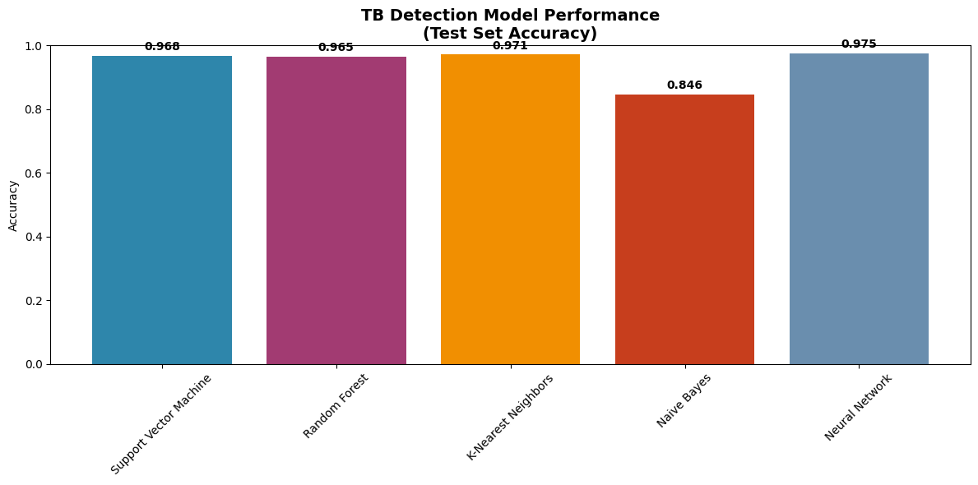
============================================================
📈 DETAILED PERFORMANCE RESULTS
============================================================

🎯 Support Vector Machine:
Test Accuracy: 0.9683
Validation Accuracy: 0.9587
Training Accuracy: 0.9670
Test AUC: 0.9827
Classification Report:
precision recall f1-score support
Normal 0.98 0.99 0.98 525
Tuberculosis 0.93 0.88 0.90 105
accuracy 0.97 630
macro avg 0.95 0.93 0.94 630
weighted avg 0.97 0.97 0.97 630

🎯 Random Forest:
Test Accuracy: 0.9651
Validation Accuracy: 0.9508
Training Accuracy: 1.0000
Test AUC: 0.9781
Classification Report:
precision recall f1-score support
Normal 0.97 0.98 0.98 525
Tuberculosis 0.92 0.87 0.89 105
accuracy 0.97 630
macro avg 0.95 0.93 0.94 630
weighted avg 0.96 0.97 0.96 630

🎯 K-Nearest Neighbors:
Test Accuracy: 0.9714
Validation Accuracy: 0.9444
Training Accuracy: 0.9612
Test AUC: 0.9718
Classification Report:
precision recall f1-score support
Normal 0.97 0.99 0.98 525
Tuberculosis 0.96 0.87 0.91 105
accuracy 0.97 630
macro avg 0.97 0.93 0.95 630
weighted avg 0.97 0.97 0.97 630

🎯 Naive Bayes:
Test Accuracy: 0.8460
Validation Accuracy: 0.8635
Training Accuracy: 0.8442
Test AUC: 0.8871
Classification Report:
precision recall f1-score support
Normal 0.91 0.90 0.91 525
Tuberculosis 0.54 0.56 0.55 105
accuracy 0.85 630
macro avg 0.72 0.73 0.73 630
weighted avg 0.85 0.85 0.85 630

🎯 Neural Network:
Test Accuracy: 0.9746
Validation Accuracy: 0.9730
Training Accuracy: 1.0000
Test AUC: 0.9857
Classification Report:
precision recall f1-score support
Normal 0.98 0.99 0.98 525
Tuberculosis 0.95 0.90 0.92 105
accuracy 0.97 630
macro avg 0.96 0.94 0.95 630
weighted avg 0.97 0.97 0.97 630

🏆 BEST MODEL: Neural Network (Accuracy: 0.9746)
💚 EXCELLENT: Potentially clinically useful

CONFUSION MATRICES

# Confusion matrices for clinical interpretation
if 'results' in locals() and results:
print("📈 CONFUSION MATRICES FOR CLINICAL INTERPRETATION")
print("=" * 50)

n_models = len(results)
fig, axes = plt.subplots(2, 3, figsize=(18, 12))
axes = axes.ravel()

for idx, (name, result) in enumerate(results.items()):
cm = confusion_matrix(y_test, result['test_predictions'])

sns.heatmap(cm, annot=True, fmt='d', cmap='Blues', ax=axes[idx],
xticklabels=['Normal', 'TB'], yticklabels=['Normal', 'TB'])
axes[idx].set_title(f'{name}\nAccuracy: {result["test_accuracy"]:.3f}',
fontweight='bold', fontsize=12)
axes[idx].set_xlabel('Predicted')
axes[idx].set_ylabel('Actual')

# Remove empty subplots
for idx in range(n_models, len(axes)):
fig.delaxes(axes[idx])

plt.tight_layout()
plt.show()

print("\n💡 CLINICAL INTERPRETATION:")
print(" Focus on False Negatives (missed TB cases) and False Positives (unnecessary worry)")

📈 CONFUSION MATRICES FOR CLINICAL INTERPRETATION
==================================================
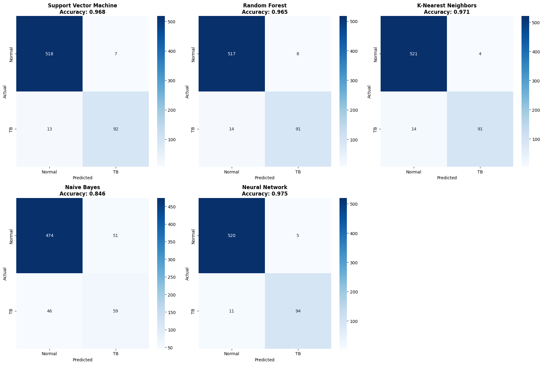
💡 CLINICAL INTERPRETATION:
Focus on False Negatives (missed TB cases) and False Positives (unnecessary worry)

